|  |  |  |  |
| --- | --- | --- | --- |
| **Course Code:** | **ECE1002** | **Course Name:** | **Semiconductor Devices and Circuits Lab** |
| **Faculty In – Charge:** | **Dr. Pradeep Naryanan. S.** | **Department:** | **SENSE** |
| **Name of the Student:** | **Aryan Pandey** | **Registration Number:** | **20BLC1087** |
| **Experiment No.:** | **3** | **Date of Experiment:** | **22.03.2021** |
| **Name of the Experiment:** | **DESIGN AND VERIFICATION OF HALF WAVE RECTIFIER WITH FILTER AND WITHOUT FILTER** | | |

**OBJECTIVE:**

To design and verify the function of the Half Wave Rectifier with and without filter using LTSPICE Simulator and observe its characteristics.

**TOOLS:**

LTSPICE XVII Simulator.

**THEORY**

**HALF WAVE RECTIFIER:**

A half-wave rectifier is defined as a type of rectifier that only allows one half-cycle of an AC voltage waveform to pass, blocking the other half-cycle. Half-wave rectifiers are used to convert AC voltage to DC Voltage. It is done by using a diode or a group of diodes.

A half-wave rectifier uses one diode, while a full-wave rectifier uses multiple diodes. The advantage of a half-wave rectifier is that it’s cheap, simple, and easy to construct. It is cheap because of the low number of components involved. Simple because of the straightforwardness in circuit design. The circuit diagram below shows the half-wave rectifier and the sample output waveform.

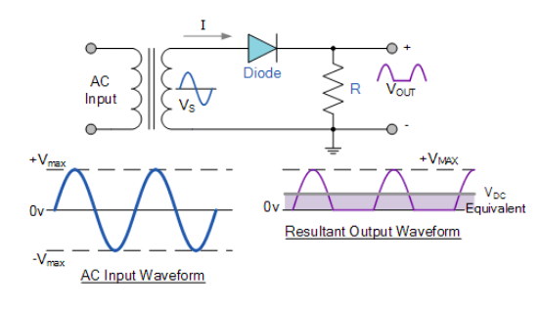

**PROCEDURE**

**WITHOUT FILTER:**

1. **Draw the AC voltage source: -**

* Transformer input is connected into the main AC supply. The normal ac input voltage is 230V and 50 Hz.
* Click on the component icon in the LT Spice and select voltage source. Right-click on the voltage source and then click on the advanced button.
* By clicking the advanced button a pop-up window will open. In this window, you will have multiple options to select. Examples “PULSE”, “SINE”, etc.
* Here we need a “SINE” waveform and provide the values in the corresponding fields.

1. DC offset= 0
2. Amplitude = 230
3. Frequency = 50Hz
4. AC amplitude = 1
5. Series Resistance = 2mΩ
6. **Draw the Transformer: -**

* Click on the inductor L1. The turns ratio of the transformer is simply a matter of choosing the right inductor values.
* Remember, the inductance is proportional to the square of the turns ratio. In the example above, a turns ratio of 3:1 gives a 9:1 inductance ratio that means the value of inductor (LP) is 2mf and the value of inductor (LS) is 2mf.
* “K LP LS 1”- K is the coefficient of coupling. Its values are between 0 and 1. “1” means the winding is perfectly coupled.

1. **Draw the Diode: -**

We need one diode here. Click on the diode button and position it on the required place on the screen. Click on the diode and click “Pick New diode” and select “1N4148 Silicon Diode”.

1. **Draw the Resister: -**

Click on the resister and position it on the required place on the screen. To give the value click on the resister and type the value. Now, the last step is to label the input and output port. To do this click on the “label net” icon. If you want to label the input port, then type Vin and port type “input”. Similarly, if you want to label the output port then type Vout and port type “output”. Then place the input and output label to the corresponding place on the screen.

1. **Simulation of Full-Wave Centre Tapped Rectifier: -**

Click on the “Simulate” button and select “Edit Simulation Command”. Now, you will see a pop-up window. For the rectifier, we have to plot the waveform in the time domain. So, we are using transient analysis here.

Click on “Transient Analysis”. And a submenu will appear. In this only enter the stop value = 100ms and click ok. Then, click the “Run” button. Run button is available in the simulate icon on the title bar.

You will see the graphical window on your screen. In order to display both the input and output simultaneously in one plane, right click on the graphic plane and click on the “add plot” plane. Then two plane will appear. For displaying the input and output, right click on the graphic plane and then click on the add traces. Here we need Vin and Vout.

**With Filter: -**

1. **Draw the AC voltage source: -**

* Take transformer input is connected into the main AC supply. The normal ac input voltage is 230V and 50 Hz.
* Construct this, click on the component icon in the LT Spice and select voltage source and Click Ok. Right-click on the voltage source, Click on the advanced button.
* By clicking the advanced button a pop-up window will open. In this window, you will have multiple options to select. Examples “PULSE”, “SINE”, etc.
* Here we need a “SINE” waveform and provide the values in the corresponding fields.

1. DC offset = 0
2. Amplitude = 230
3. Frequency = 50HZ
4. AC amplitude = 1
5. Series Resistance = 2mΩ
6. **Draw the Transformer: -**

* Right-click on the inductor L1 and name it as LP then click on L2 and name it as LS and the turns ratio of the transformer is simply a matter of choosing the right inductor values.
* Remember, the inductance is proportional to the square of the turns ratio. In the example above, a turns ratio of 3:1 gives a 9:1 inductance ratio that means the value of inductor (LP) is 2mf and the value of inductor (LS) is 2mf.
* “K LP LS 1”- K is the coefficient of coupling. Its values are between 0 and 1. “1” means the winding is perfectly coupled.

1. **Draw the Diode: -**

We need one diode here. Click on the diode button and position it on the required place on the screen. Click on the diode and click “Pick New diode” and select “1N4148 Silicon Diode”.

1. **Draw the Resister: -**

Click on the resister and position it on the required place on the screen. To give the value click on the resister and type the value. Now, the last step is to label the input and output port. To do this click on the “label net” icon. If you want to label the input port, then type Vin and port type “input”. Similarly, if you want to label the output port then type Vout and port type “output”. Then place the input and output label to the corresponding place on the screen.

1. **Draw a Capacitor: -**

Place it in the required position with 100µF of Capacitance and then add ground to both the Primary and Secondary coil.

1. **Simulation of Half-Wave Rectifier: -**

Click on the “Simulate” button and select “Edit Simulation Command”. Now, you will see a pop-up window. For the rectifier, we have to plot the waveform in the time domain. So, we are using transient analysis here.

Click on “Transient Analysis”. And a submenu will appear. In this only enter the stop value = 100ms and click ok. Then, click the “Run” button. Run button is available in the simulate icon on the title bar.

You will see the graphical window on your screen. In order to display both the input and output simultaneously in one plane, right click on the graphic plane and click on the “add plot” plane. Then two plane will appear. For displaying the input and output, right click on the graphic plane and then click on the add traces. Here we need Vin and Vout.

**VERIFICATION OF HALF WAVE RECTIFIER**

**WITHOUT FILTER: -**

* A simple Half Wave Rectifier is nothing more than a single pn junction diode connected in series to the load resistor. As you know a diode is to electric current like a one-way valve is to water, it allows electric current to flow in only one direction. This property of the diode is very useful in creating simple rectifiers which are used to convert AC to DC.
* We are giving an alternating current as input. Input voltage is given to a step-down transformer and the resulting reduced output of the transformer is given to the diode “D” and load resistor RL. The output voltage is measured across load resistor RL.

**Components Required: -**

* Resistors
* Wires
* Ground
* Diode
* Voltage Source

**Logic Diagram: -**

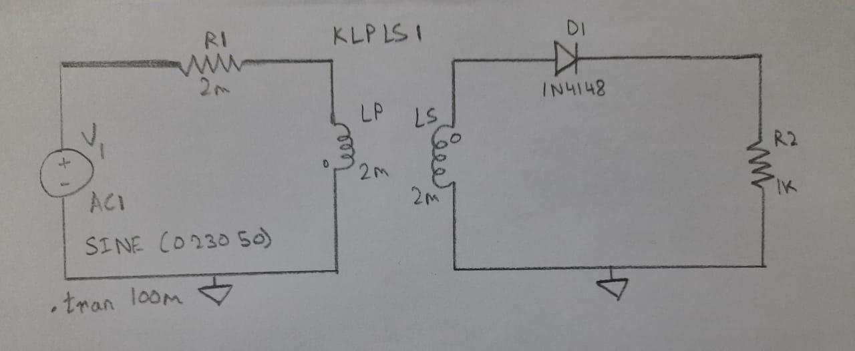

**Simulator Diagram – Schematic: -**

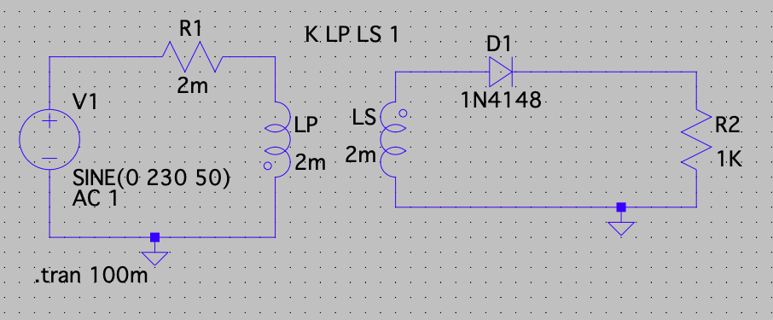

**Outputs: -**

**Input Waveform: -**

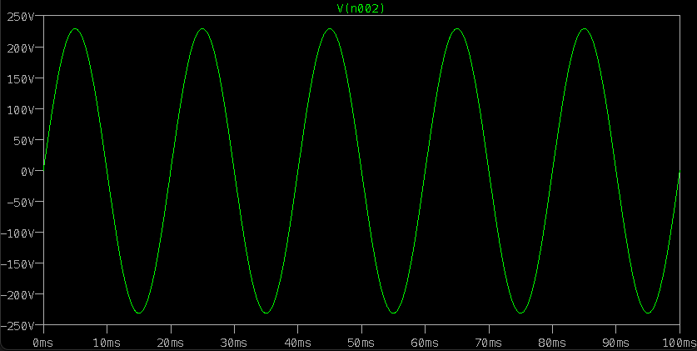

**Output Waveform: -**

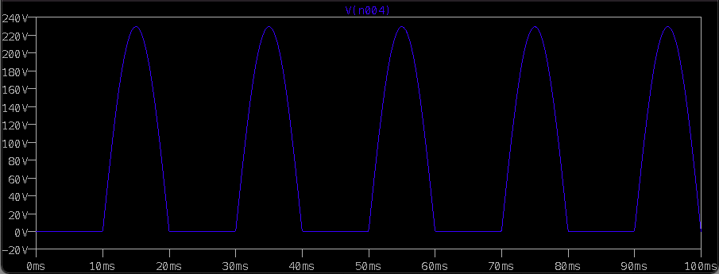

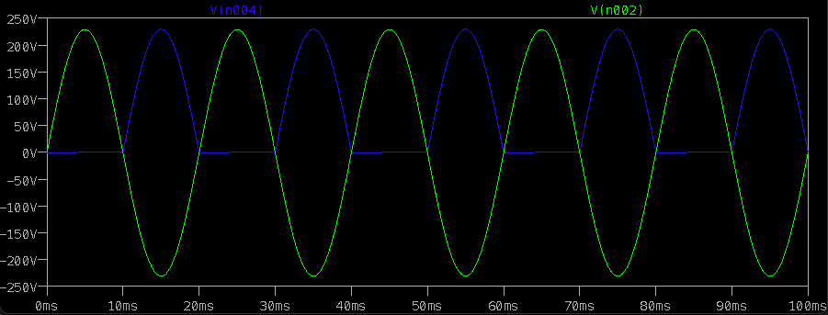

**WITH FILTER: -**

The half wave rectifier converts the Alternating Current(AC) into Direct Current(DC). But the obtained Direct Current (DC) at the output is not a pure Direct Current (DC). It is a pulsating Direct Current (DC).

The pulsating Direct Current (DC) is not constant. It fluctuates with respect to time. When this fluctuating Direct Current (DC) is applied to any electronic device, the device may not work properly. Sometimes the device may also be damaged. So the fluctuating Direct Current (DC) is not useful in most of the applications.

Therefore, we need a Direct Current (DC) that does not fluctuate with respect to time. The only solution for this is smoothing the fluctuating Direct Current (DC). This can be achieved by using a device called filter.

The pulsating Direct Current (DC) contains both AC and DC components. DC components are useful but AC components are not useful. So we need to reduce or completely remove the AC components. By using the filter, we can reduce the AC components at the output.

**Components Required: -**

* Resistors
* Wires
* Ground
* Diode
* Voltage source
* Capacitors

**Logic Diagram: -**

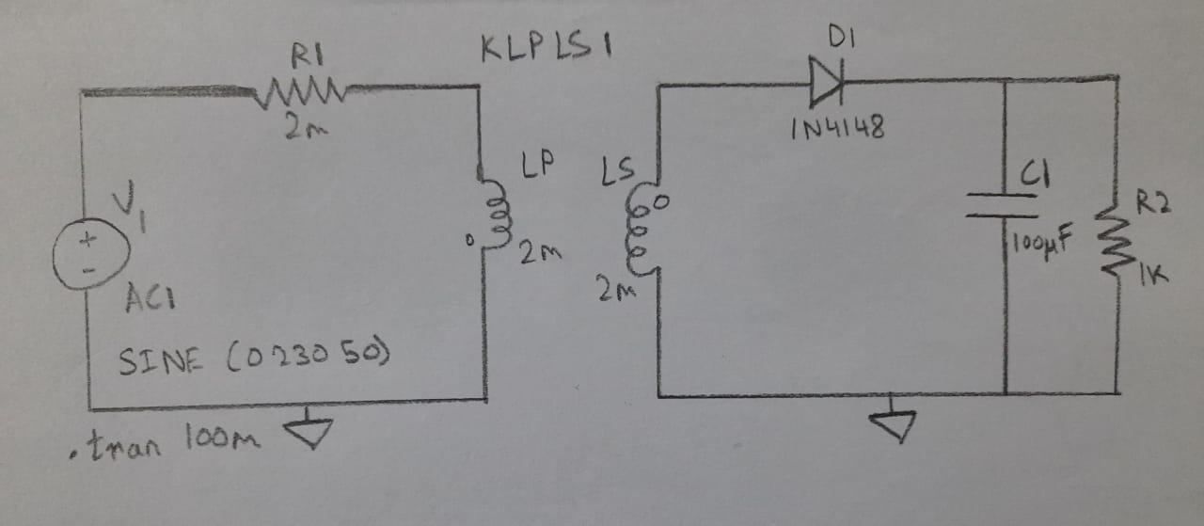

**Simulator Diagram – Schematic: -**

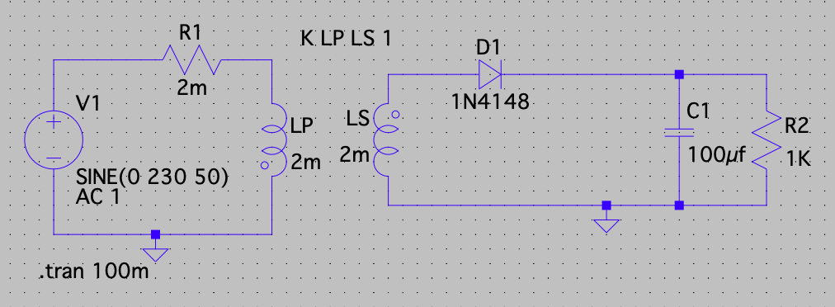

**Outputs: -**

**Input Waveform: -**

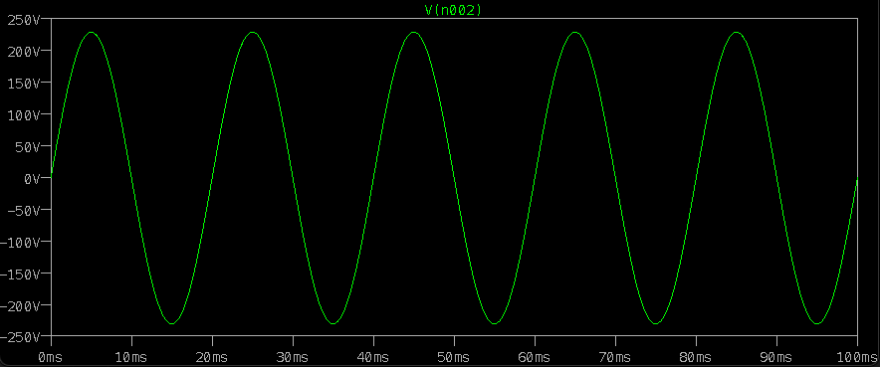

**Output Waveform: -**

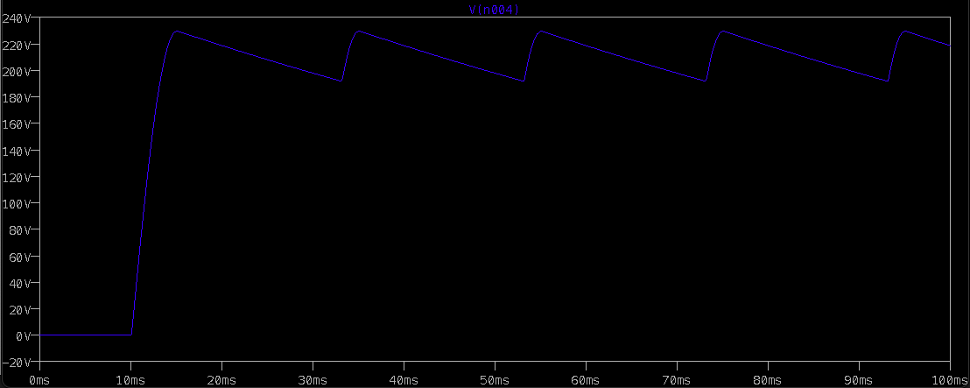

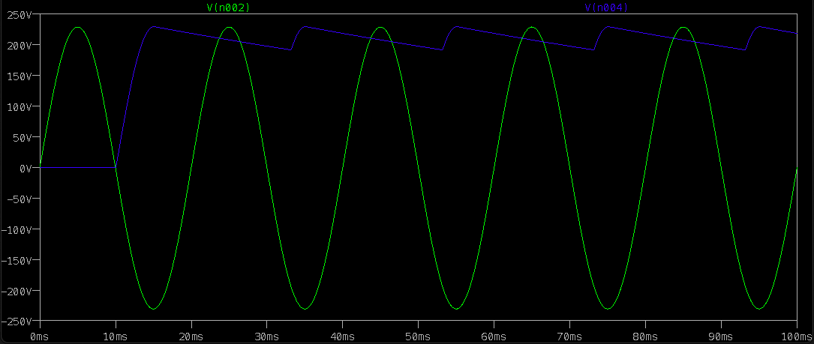

**INFERENCE**

**Without Filter: -**

When a single diode unit is placed in series with the load across an ac supply, it rectifies the signal and converts alternating voltage into a unidirectional pulsating voltage i.e. id DC signal.

One-half cycle of the applied voltage is passed but the other half cycle is suppressed because it conducts only in one direction. Unless there is an inductance or battery in the circuit, the current will be zero. This is called “half-wave rectification”*.*

During the positive half-cycles of the input ac voltage *i.e.*when the upper end of the secondary winding is positive w.r.t. its lower end, the diode is forward biased and therefore conducts current. If the forward resistance of the diode is assumed to be zero, the input voltage during the positive half-cycles is directly applied to the load resistance “RL”, making its upper end positive w.r.t. to its lower end. The waveforms of the output current and output voltage are of the same shape as that of the input AC voltage.

**With Filter: -**

The capacitor provides high resistive path to DC components which is a low frequency signal and low resistive path to AC components which is a high frequency signal.

Electric current always prefers to flow through a low resistance path. So when the electric current reaches the filter, the DC components experience a high resistance from the capacitor and ac components experience a low resistance from the capacitor.

The dc components does not flow through the capacitor which is a high resistance path. So they find an alternative path which is low in resistance and flows to the load resistor (RL) through that path.

On the other hand, the AC components experience a low resistance from the capacitor. So the AC components easily passes through the ‘Capacitor’. But a small part of the ac components passes through the load resistor (RL) producing a small ripple voltage at the output.

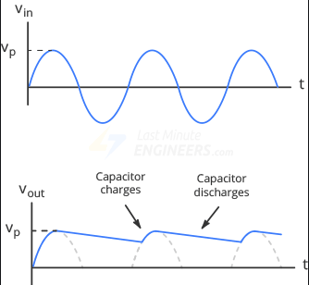

In simple words, the AC components is nothing but an excess current that flows through the capacitor and charges it. During the conduction period, the capacitor charges to the maximum value of the supply voltage.

When the negative half cycle is reached, the diode D gets reverse biased and stops allowing electric current through it. During this non-conduction period, the input voltage is less than that of the capacitor voltage. So the capacitor discharges all the stored charges through the load resistor RL. This prevents the output load voltage from falling to zero.

The capacitor discharges until the input supply voltage is less than the capacitor voltage. When the input supply voltage is greater than the capacitor voltage, the capacitor again starts charging.

The capacitor filter with a large discharge time constant will produce a very smooth DC voltage.

Thus, a smooth and steady DC voltage is obtained by using the filter.

**RESULT: Half wave rectifier output and input characteristics with and without filter is verified.**